### How to Create PayPal Account In Kenya and link with Mpesa

# Step 1: Visit <https://www.paypal.com/ke/>

When you click the link, it takes your here:

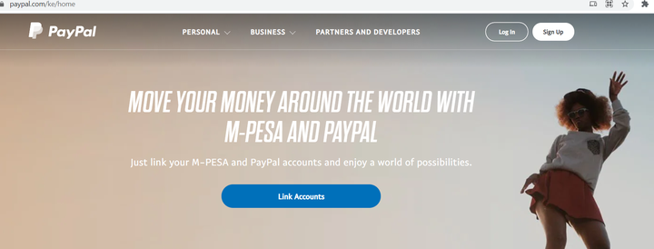

# Step 2: Click Signup

The button appears at the top right-corner

# Step 3: Select Personal Account

The purpose of selecting personal account is that it allows you to shop within your country as well as the globe using your smart device. Below is the illustration:

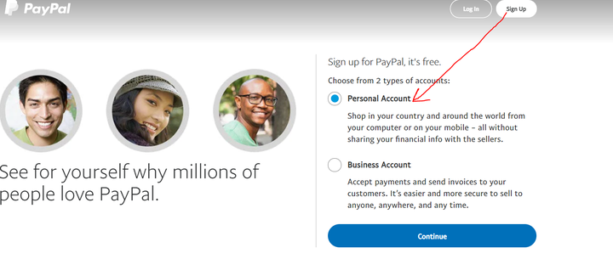

Once you choose personal account, click **Continue.**

# Step 4: Add your phone number then Click Next

Make sure the phone number is active and registered under your names. Below is how it appears:

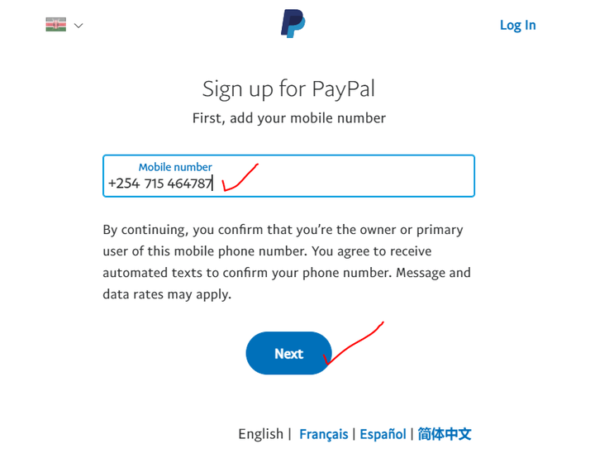

# Step 5: Insert the 6 digit code sent to the number

A code is sent to the number you provided in step 4. It has 6 digits:

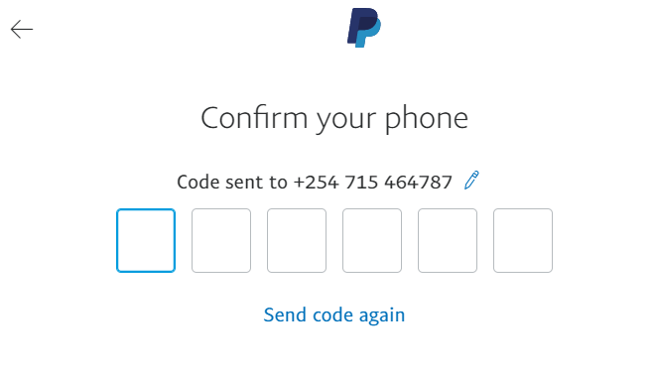

# Step 6: Fill personal details

They include genuine email address, First and Last name as they appear in your National Identification Card. Then create a strong password with at least 8 characters. You can combine lowercase and uppercase characters, digits and special characters such as @ and #.Fill the form as shown below then click **Next:**

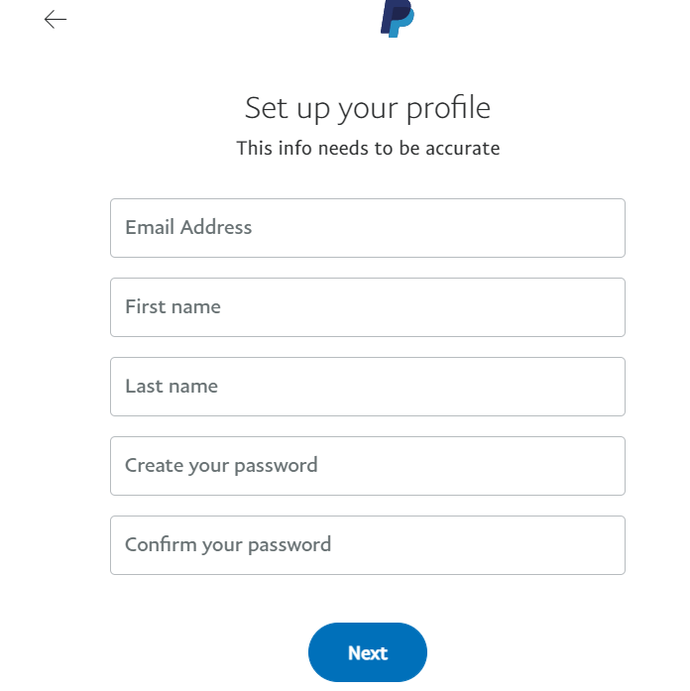

# Step 7: Fill address details

You are required to select the National ID, then write its number, address location, city, postal code and the date of birth. Fill the details then click **agree and create account**:

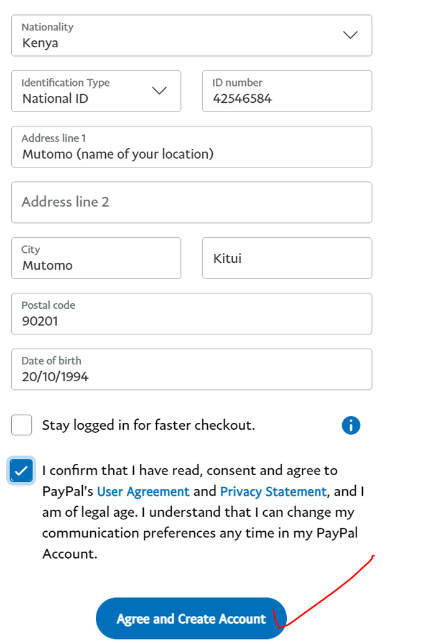

# Step 8: Login to your email

Once you login, open the message then click confirm my email address.

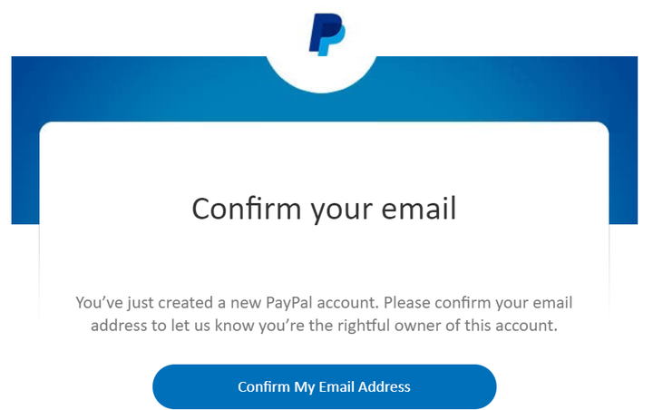After confirmation, you will be redirected to login your PayPal Account. Now your account is active. If you are told to link card or bank, skip that.

# Step 9: Close the Current tab and open <https://www.paypal.com/>

You will be directed to login. Use the email and password used in step 6 to login. You will be directed to the dashboard as shown below:

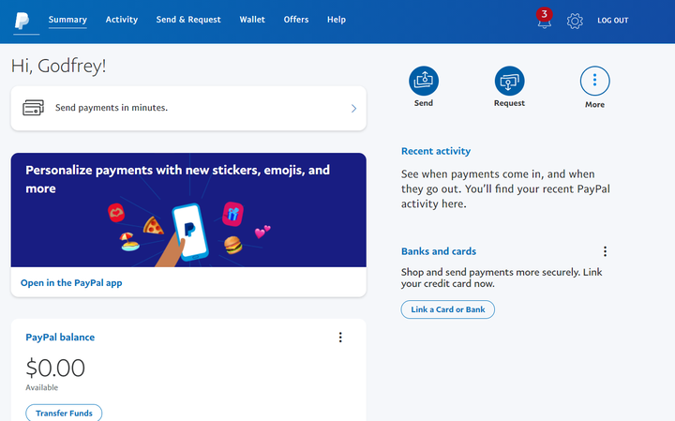

If your account looks like above, you are done creating PayPal. Your PayPal ID is the email you used to create PayPal

**Part 2: Link PayPal with Mpesa**

Step 1: Open the link <https://www.paypal-mobilemoney.com/m-pesa> It will open the page shown:

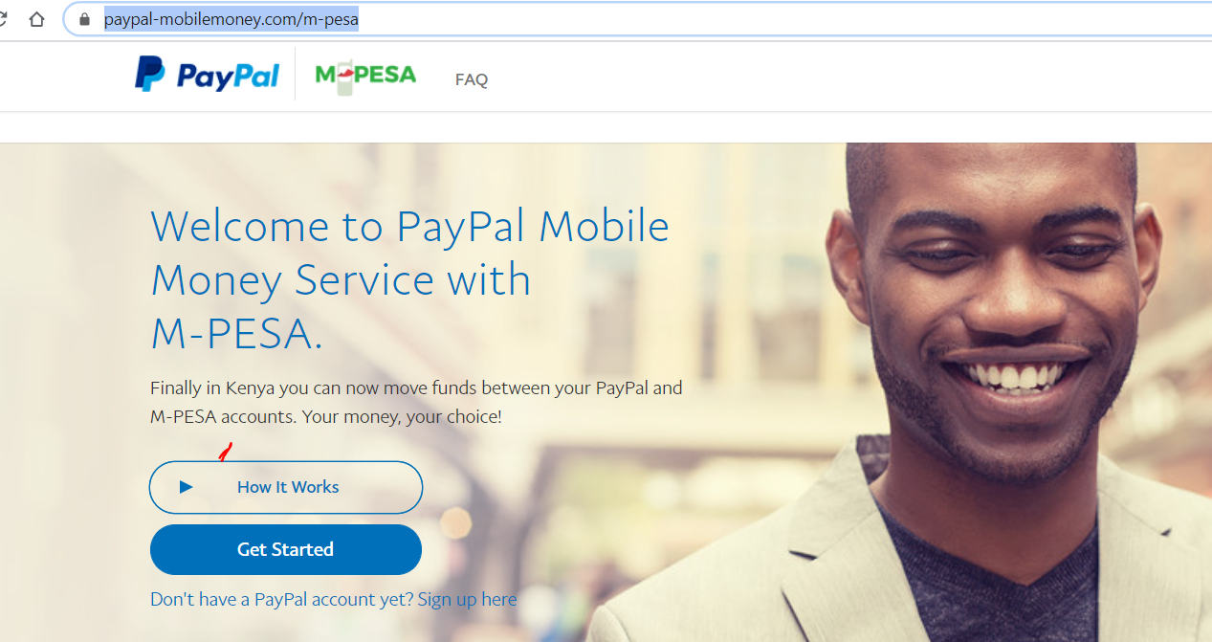

Step 2: Click Get started. If you are directed to login to your PayPal, please login using the email and password used.

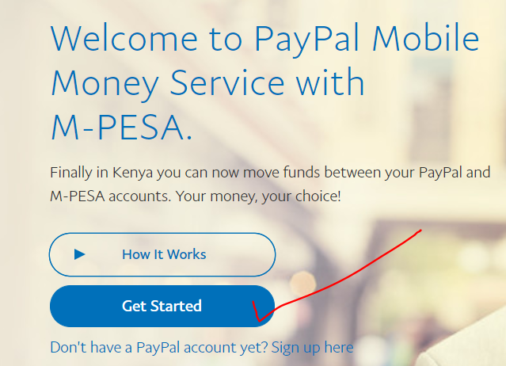

Step 3: A popup opens for terms, scroll down and Click **agree**

Step 4: Adding Mpesa Number starting from 7 or 1

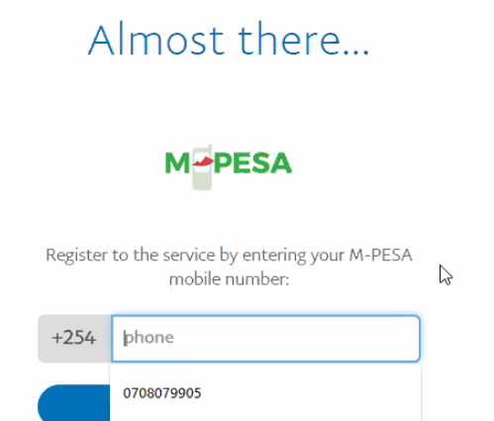

Step 5: Enter the 4-digit code sent to the Mpesa number then click **Confirm**

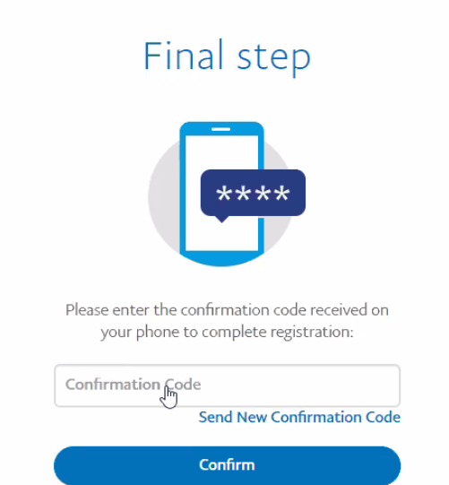

Step 6: It will be linked as shown below:

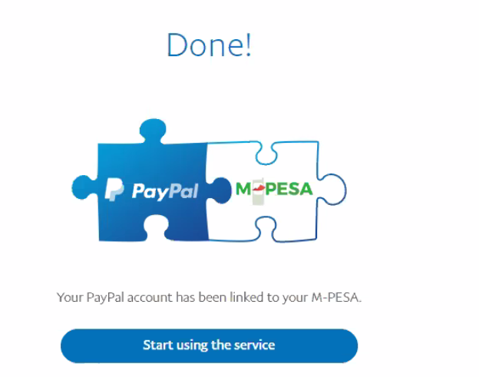

Step 7: Click Start using the service. That is DONE as shown:

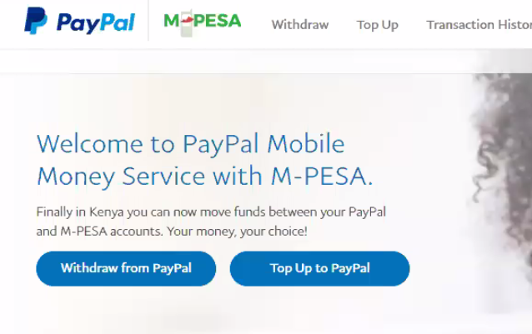

NB// If you have money in your PayPal, you will be clicking Withdraw from PayPal then asked the amount to withdraw. The money will be sent to your Mpesa.